How to use Search Engine Optimization in today's world
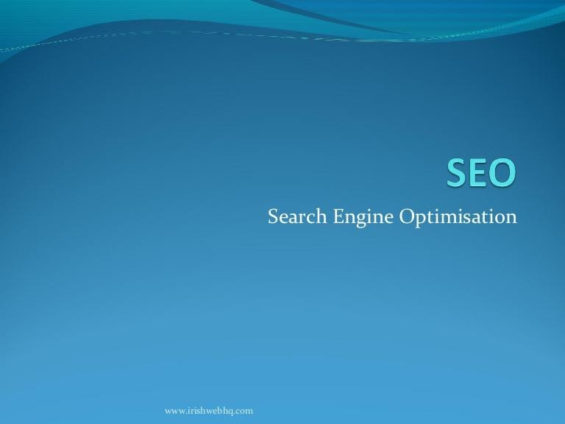
In this article, you're making an attempt to inform that you simply can rank your web site by search engine improvement and you'll simply develop your business

What is Digital Marketing?

Digital marketing is that the term used for the targeted, measurable and interactive marketing of product and services, exploitation digital technologies to realize audiences.

However, though digital is totally completely different from ancient marketing?

ancient ways of selling advertisements for your business or services are adopted where the work wasn't in serious trouble advertising in print media, radio and television advertising, business cards.

Bill boards and on your net or social media websites Ancient marketing policies restricted buying customer behavior and driving behavior.

Digital marketing achieves the goal of promoting the business through varied on-line channels. Let' see how.

What is search engine optimization?
search engine marketing refers to go looking engine optimization.
Relevant Searches your page's If the search engine marketing rating of your internet site isn't good, then you may paintings unnecessarily Potential and current clients on your business.
SEO Technique

On-page SEO = generally determined as ‘on-site SEO is that the strategy of optimizing the content of a webpage for pc programs.
the ultimate word goal of on-page SEO is to speak the ‘search engines’ language’ and facilitate program crawlers understand the meaning and context of your pages.
Off-page SEO = refers back to the strategies that you may be capable of use to growth the status. This is a way this is out of doors of the website.
SERPs bring about pc applications that bring about an Internet web website online web page.
Many folks Off-web page search engine marketing with hyperlink constructing but it's far over.
In general, what off-web page search engine marketing has to do with promotional methods - the farthest Website content - meant to present better rating to a web web website online Search result.

Why is SEO important for marketing?
SEO may be a basic a part of digital sales nowadays a lot of and more folks rummage around for one thing a day
typically with business intentions to search out knowledge relating to merchandise and services.
Search is sometimes the primary offer of digital traffic to counterpoint brands and different promoting channels.
However, over the years, search results are evolving to supply additional direct answers and knowledge to users.
Who are more skeptical of putting users on the results page than visiting varied websites.

What is keyword research in SEO?

Keyword studies is that By this you examine not unusualplace seek phrases humans Google and serps like Yahoo, and consist of them strategically to your Content.

Looks High on Hunt Engine Results Page SERP key-word analysis may be a number one utility in serps Optimization

What is a title tag?

If you have got ever used a pursuit engine before, you have seen a page title tag or not, you have completed it or not.
It tells concerning the subject of your web site the keyword that's being searched the foremost is that the hollow in your website, which is able to increase your ranking, that has become sensible for your website.

Is Meta Description a Google ranking factor?

The Meta Description does now no longer look like a right away rating factor. Google has been very clean on that. It need to be very untouched.
Which any person need to realize approximately your pages beforehand, what you need to mention withinside the description.
So including your goal key-word to the Meta Description of a web page does now no longer deliver it a right away boost. But The meta description has an oblique impact withinside the Associate in Nursing rating Like this.

A Very Good Content Import

Forget the advertising and additionally the dry press release. Audiences have wised up, so provide them high-quality content that they're going to terribly have interaction with.

For anyone who’s knowledgeable about the next phrase bellowed at them across the space by a senior government “we have to be compelled to get into content

selling everyone’s doing it, Coca-Cola’s doing it, BMW is doing it, Red Bull is doing it, we should always always be doing it too” then this is often often for you

Content promoting is everyone’s favorite hot new digital marketing phrase right now, nevertheless the truth is that whereas the label has big in.

popularity, the notion that content promoting are a few things new isn’t quite correct.

Guest blogging
Guest blogging is one amongst the foremost effective ways that to explore you rself Internet. this is often a decent issue in your already established audience.
you'll increase your web site ranking and this is a good technique. this is often a technique to rank a website. nice for building further followers on social media, driving traffic, as furthermore build quality back links.
Conclusion: = In this, looking to apprehend how you could rating your internet site from search engine optimization and you could expand business.

